Driven to distraction:
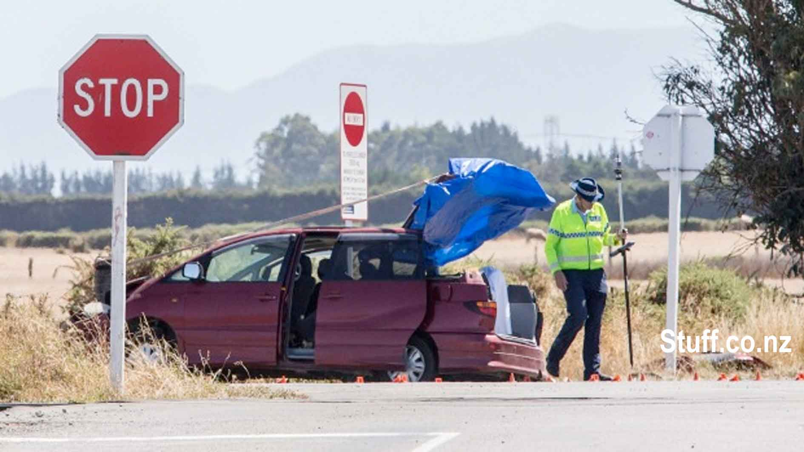
a strategy for reducing tourist accidents

Clive Matthew-Wilson, editor, dogandlemon.com
October, 2014
First revision, April 2015

Table of Contents

Table of Contents
Executive summary
Introduction
Severity of accidents
Tourist accidents an international problem
Older vehicles involved
Longer term visitors buying older vehicles
Tourist accident characteristics
Global factors and factors more unique to New Zealand
Factors more unique to New Zealand
Vehicles
Confusion
Unfamilarity with high-speed rural roads
Time pressures
Fatigue
Fatigue-related accidents likely due to ‘sleep debt’
Travellers need more sleep, not less
Familiarity breeds carelessness
Consequences of compulsory stand-down period prior to renting vehicles
Cultural attitudes to danger
Roading, behavioural and vehicle factors, and how they combine to contribute to road deaths
The lack of warning to the driver before he drifted off the road
Road condition
No Electronic Stability Control on the vehicle
Real solutions versus soft options
1. No mandatory code of road safety practice for rental industry
2. Education ineffective
3. Rental vehicles only half the problem
Transportation efficiency versus safety
Useful steps to lower the tourist road toll
Restrictions on the rental of cars to recently arrived drivers
Centralised control of driver eligibility
Restrictions on who can rent and buy vehicles
Standardised driver cognisance test
Structure of the proposed cognisance test
Changes to road conditions
Improvements to the rental vehicle fleet
Encouragement of alternatives to self-driving
Statistics contained within Rumble strips, median barriers needed to make roads safer

Executive summary
Tourist drivers, internationally, have a significantly higher rate of motor accidents than the residents of the Western countries they visit. The reasons are multiple, but the solutions involve a combination of enforcement and engineering, to ensure that normal human mistakes do not grow into serious accidents.

While improvements in road and vehicle engineering are likely to reduce both the number and severity of tourist-related accidents in the future, these steps will take years to implement. Urgent changes are needed in the short term to reduce both accidents and their severity.

These solutions can be summarised as follows:

- Restrictions on the renting of vehicles to tourists within a fixed period of arrival from overseas.
- An interactive, computer-based competency assessment that must be completed before a vehicle can be rented. The same test should apply before a vehicle ownership be transferred, if the purchaser of the vehicle is using a foreign passport or international driver’s licence as identification at the time of transfer.
- Register of recently arrived foreign drivers hiring rental vehicles in New Zealand.
- Rental companies would be required to lodge details, in an NZTA database, of vehicle hires to individuals where their passport shows they have arrived in the country within the previous month. Where police have concerns about the operation of any vehicle by a foreign driver, they should have the power to restrict the use of further vehicles by that driver.
- Changes to road engineering, including the widespread modification of road signage, and:
  - Repositioning of marker lines.
  - Elimination of gravel on the verges of sealed arterial and popular tourist local roads.
  - Installation of rumble strips to alert drivers to possible danger, together with the installation of median barriers, where practicable, to prevent cars moving into the wrong side of the road.
  - Improvements at major intersections, including improved signage, rumble strips and intersection construction, to lessen the risk of collisions at these points.
- Set minimum standards for rental vehicles:
  - All rental vehicles must meet reasonable crash standards.
  - All rental vehicles to have electronic stability control.
- The encouragement of alternatives to self-driving.

Introduction

Throughout the summer of 2014-15, road accidents involving foreign tourists were an almost daily occurrence. With the growing tide of accidents came an unprecedented level of interest from both the news media and the public, until the issue dominated many media outlets.

South Island drivers were reported as being both fed up and fearful of venturing out onto highways, due to the probability of their becoming the latest innocent victim of an accident with a tourist.

Vigilante action by well-meaning - but possibly misguided – individuals, began to appear, a sign of frustration with what was perceived to be a lack of effective action on the part of the Government and rental car companies.

While the police were quick to call for restraint, urging motorists not to take the law into their own hands, some motorists ignored this call. The view in many remote South Island towns was that the police were often distant, cellphone coverage was inconsistent and the threat immediate. Ergo, these vigilantes saw themselves as conscientious motorists “doing their best to avoid further carnage” by confiscating the vehicle keys of tourist drivers who were perceived to be a threat on the local roads.

Due to the delays in the gathering of statistics, most hard data about tourist accidents is historical.

Foreign visitors were involved in nearly 600 road accidents resulting in death or injury on New Zealand roads in 2013.

The situation in New Zealand is often more complex than it first appears. While the percentage of accidents involving tourist drivers has been slowly trending up for the past 20 years, it is still lower than it was in 2012.

Research conducted by the NZ Herald, using the New Zealand Transport Agency’s (NZTA) Crash Analysis System (CAS), noted that in 1994, death or injury accidents involving tourists were just 0.7%. By 2012, this figure had grown to 4.2%, largely due to the increase in tourist drivers.
In 2013, this figure had dropped to 2.9%. However, these recent variations in percentages may be simply the normal variations that mysteriously affect the road toll, without affecting the overall trend.

One significant factor is location of accidents: while the national figure is quite low, in certain locations, such as Westland, the percentage is around 37%; an alarming figure given the relatively small amount of traffic using those roads.

Tourist crashes by region (top 20), 2009-2013
Area | Percentage who were foreign drivers | Number of crashes involving foreign drivers
Westland | 37 | 76
Mackenzie | 27 | 34
Southland | 25 | 173
Queenstown-Lakes | 24 | 104
Kaikoura | 22 | 24
Central Otago | 17 | 45
Buller | 13 | 23
Ashburton | 13 | 40
Tasman | 12 | 60
Hurunui | 12 | 35
Waitaki | 12 | 46
Ruapehu | 11 | 32
Clutha | 11 | 47
Marlborough | 11 | 57
Waitomo | 10 | 26
Far North | 9 | 84
Thames-Coromandel | 9 | 36
Taupo | 8 | 50
Selwyn | 8 | 43
Western Bay of Plenty | 8 | 51

Severity of accidents
While tourists driving rental vehicles actually make up a small percentage of crashes within New Zealand, this group appears to be involved in a disproportionately high rate of serious incidents.
Accordingly, these accidents are worthy of separate scrutiny, with a particular emphasis on effective measures to reduce the likelihood of similar incidents in the future.

Tourist accidents an international problem
The problem of tourist accidents is by no means restricted to drivers from Third World countries. Although most accidents involve drivers from countries that drive on the opposite side of the road, a quarter of tourist accidents involve drivers from Australia and Britain.

The overall pattern of tourist accidents seems to loosely fit the profile of the tourists most likely to be driving here. That is, the tourists appear to range from young backpackers to family groups on holiday. The duration of their stay, the distances they travel, the destinations that they travel to, and the type of vehicles they are driving vary widely.

Global factors and factors more unique to New Zealand
The New Zealand situation is part of a global phenomenon. The following is a quote from the book: Managing Tourist Health and Safety in the New Millennium, Jeff Wilks, J Stephen, F. Moore (2013).

“There is a large body of literature on tourist behaviour [which is presented as if] the ‘tourist’ is something outside of normal society, a separate entity from the ‘resident’ [of that locality]. The ‘tourist’ in reality, is one community member visiting another community. Yet in the transformation from ‘resident’ to ‘tourist’, there [are clearly] behavioural changes…Tarlow (2000) identifies six characteristics that make tourists more vulnerable [to acts of crime, but, for similar reasons, to vehicle accidents]:

Issues of trust – the tourist may believe that his destination choice is safer than [his or her] normal place of residence, resulting in behaviour that is more ‘naïve’ than the local residents.

Alienation from place – the tourist [may be] unfamiliar with the area and many have few connections to it. They may also seek higher levels of adventure, further separating them from the local populace.

Anomic behaviour – the tourist may [drop their] usual social or ethical standards as they consume their ‘holiday experience’.

Cerebral hygiene – as part of the holiday experience, the tourist is often seeking to clear the mind, and in doing so, may relax normal defence mechanisms.

Lowering of inhibitions – for many, being out [of] their normal environment releases them from their normal constraints and inhibitions, leaving them vulnerable…

These behavioural aspects, combining with the different risk levels identified earlier, can bring about undesirable consequences that the tourist cannot easily deal with…”

The Paris-based Fédération Internationale de l'Automobile (FIA), also had the following to say about risks that tourist drivers face in a foreign country:

“Research undertaken in Australia, New Zealand and the UK on the underlying causes has identified a number of additional tourist-specific risks (e.g. unfamiliarity, disorientation, distraction and fatigue).

Tourists are more at risk when they are not well prepared, where there is insufficient harmonisation in road safety practices (e.g.: pedestrian priority at pedestrian crossings) or they are involved in risky behavior (e.g.: speeding, drink-driving and not wearing a seat-belt or crash helmet).”

Factors more unique to New Zealand

Tourist accident characteristics

Analysis of at-fault crashes in Otago and Southland
Timing | Mostly occurred during day time
Timing | Only 10% were during official holiday periods
Location | Clustering of crashes around Queenstown, Cromwell, along SH94 to Milford, and SH6
No other vehicle involved | Nearly two thirds were single vehicle crashes
Road factors | A little under half were on straight sections of road
Road factors | Road factors contributed to a fifth of these crashes
Road factors | A third of these crashes hit a bank or went over an embankment
Speed zones | Three quarters occurred in 100km/h zones
Driver age and sex | At-fault drivers were mostly younger than 40 years
Driver age and sex | Two thirds were male
Driver age and sex | A larger number of overseas drivers aged 20 to 29 years old were at fault compared to New Zealand full licence drivers of the same age group

Older vehicles involved

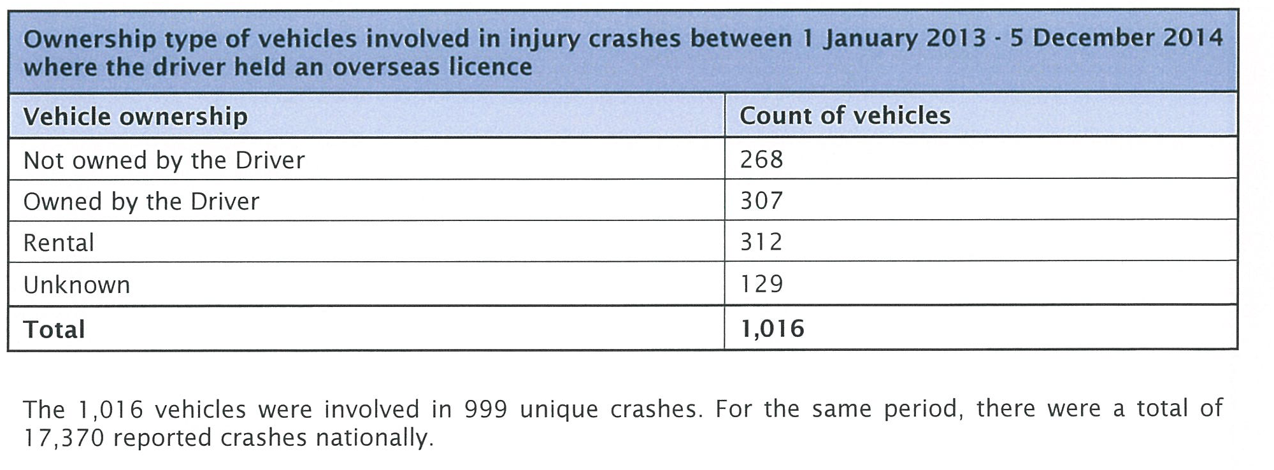

The chart above is for a single year. Other studies have indicated that about half of tourist accidents where the tourist was at fault, involve rental vehicles.

Vehicle ownership
Half, 51%, of vehicles being crashed by at-fault overseas drivers were rental vehicles.
As this would be expected of a visitor to NZ, it should then be noted what seems a high level of ownership, 21%.

However, these vehicles are not necessarily the shiny new cars that most people associate with tourists. The same researcher describes them as being comparable with the age of the New Zealand vehicle fleet, which is quite old by global standards (about 13.5 years).

This is loosely consistent with a list of vehicles involved in injury accidents between 1 January 2013 - 5 December 2014 where the driver held an overseas licence, obtained from the NZTA under the Official Information Act, which showed that the average age of the vehicles was in fact around 11.73 years old (average excluding 'age not recorded').

Thus, the age of the vehicles, perhaps combined with the age and background of persons renting or buying these older vehicles, appears to be a significant factor in the tourist road toll.

 | Age of vehicles involved in injury crashes between 1 January 2013 - 5 December 2014 where the driver held an overseas licence
 | Vehicle Age | Count of Vehicles
 | 0 | 25
 | 1 | 78
 | 2 | 42
 | 3 | 27
 | 4 | 20
 | 5 | 23
 | 6 | 37
 | 7 | 53
 | 8 | 52
 | 9 | 55
 | 10 | 49
 | 11 | 25
 | 12 | 39
 | 13 | 34
 | 14 | 35
 | 15 | 25
 | 16 | 41
 | 17 | 67
 | 18 | 76
 | 19 | 56
 | 20 | 40
 | 21 | 25
 | 22 | 24
 | 23 | 21
 | 24 | 7
 | 25 | 5
 | 26 | 3
 | 27 | 1
 | 30 | 1
 | 31 | 1
 | 43 | 1
 | 54 | 1
 | Age not recorded | 27
 | Total | 1016

Exactly which vehicles were rentals and which were privately owned does not appear to have been recorded in the above chart.

However, there is strong evidence of older rental vehicles playing a significant role in the tourist road toll, the most obvious being the multiple fatality in Turangi, detailed below.

According to the NZTA, the average age of rental cars in New Zealand is about five years.

“ 49% (18,455) of rental cars are two years of age or less. However, the average age is five years because rental cars include vintage and classic vehicles offered for hire by Rental Service Licence (RSL) holders.”

However, this statement does little to explain the significant percentage of tourist accidents that appear to involve older vehicles. Few, if any, of the tourist accidents we are aware of involved vintage or classic vehicles.

A more plausible explanation is that specific rental firms are targeting tourists on a budget, offering vehicles that would be considered obsolete in much of the developed world.

For example, Abell Rentals is offering cars that are up to 23 years old and are thus completely lacking even the most basic modern safety equipment, such as frontal airbags.



Similarly, Discount Car Rental claims to have 1000 vehicles. These vehicles range in age from 2003 to 2014, but with a heavy leaning towards older, cheaper vehicles. For example, of the two vans offered in the ‘people-mover’ category, one is a 2000-2003 Toyota Estima. As with a significant percentage of the vehicles being offered, this vehicle lacks Electronic Stability Control.



Perhaps even more disturbing is the large number of smaller firms specifically targeting the cheapest end of the backpacker market. The illustration below is from Auckland company Escape Car Rentals.



The vehicle in the photo is a Toyota Hiace, from the years 1990-2005. It has virtually no frontal impact protection, little or no side impact protection; most versions have no airbags, together with dangerous lap-only seatbelts in middle and many rear positions (depending on the model) and no ABS braking. All versions lack Electronic Stability Control.

Due to these multiple safety omissions, this van, with its high centre of gravity and crude suspension, will not only be unstable in emergency situations, but highly likely to kill or injure its occupants in any significant accident.

So, some of the highest risk vehicles on the road are being rented to some of the highest risk drivers on the road: young adults on holiday.

As with the Turangi example detailed below, this is a perfect setup for a multiple fatality.

2. Longer term visitors are buying older, cheaper vehicles.

Not all tourist vehicles that crash are campervans or even rental vehicles.

As we can see from the chart immediately above, slightly less than one third of the vehicles involved in accidents were owned by the drivers. Based on the ages of the vehicles listed in the previous chart, it appears that many of this group are younger drivers, here for a longer time, buying cheap vehicles in order to avoid the higher costs of renting a vehicle for an extended period.

It must be noted also that there are a large percentage of vehicles in the chart immediately above, that were listed as ‘not owned by the driver’ or ‘unknown.’

It seems plausible that a significant percentage of the ‘not owned by the driver’ vehicles were owned by another occupant of the vehicle, who was sharing the driving.

Also, in some cases, it seems equally plausible that some vehicles were simply passed from one backpacker to another without anyone bothering to change ownership. Under New Zealand law (with exceptions), the owner of a vehicle is liable for fines incurred in his or her vehicle. However, backpackers seem generally aware that it’s hard for the New Zealand authorities to enforce fines once the backpacker has left the country, presumably never to return.

It is also possible that some of these vehicles were illegally rented to backpackers by these vehicles’ New Zealand owners (we have heard rumours of this, but cannot provide any credible verification).

Lack of stability control
A significant number of accidents appear to involve vehicles without electronic stability control. Electronic stability control was specifically designed to prevent the kind of loss-of-control accidents that feature highly in tourist accident statistics.

Confusion
Many tourists come from countries where motor vehicles drive on the opposite side of the road. There is often confusion during certain manoeuvres, such as navigating through intersections, combined with a tendency for the driver to instinctively lurch to the wrong side of the road in emergency situations.

Poorly marked intersections
There have been multiple accidents at rural intersections where a visiting driver drove straight through a STOP sign, apparently unaware that it was there. A recent tragic example of a tourist missing a compulsory stop sign was a fatal crash at Leeston, near Springston. A 26-year-old German man failed to give way at a STOP sign at the intersection of Goulds Rd and Leeston Rd near Springston. The German man’s Honda Odyssey crashed into the driver side door of a Toyota Corolla carrying Leeston woman Stephanie Anne Ellis, 54. Ellis, a teacher aide, was freed by firefighters but later died at the scene.

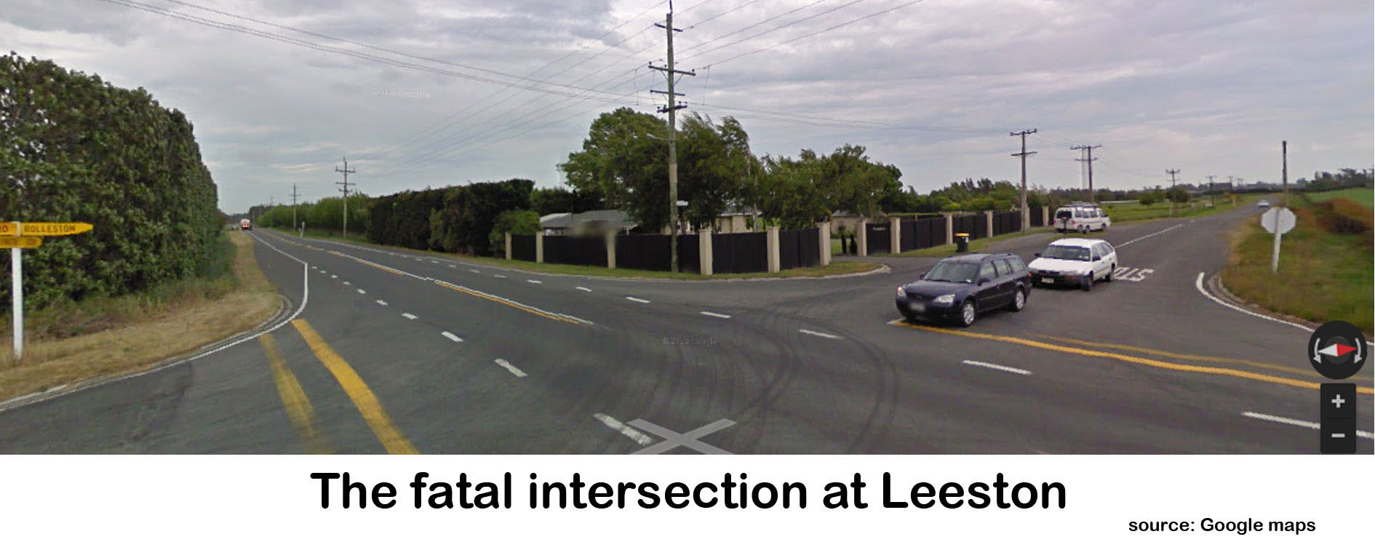
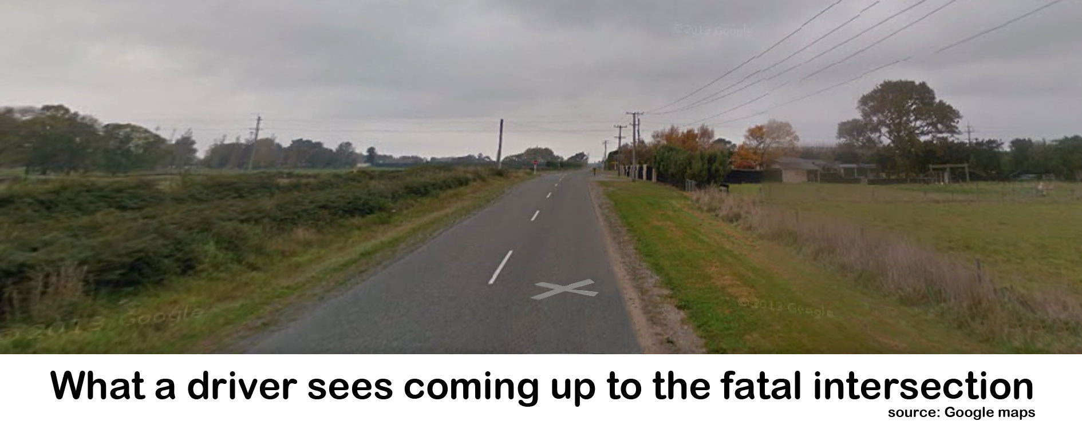
It appears that this driver, as with many others, simply did not see the intersection as he approached. This is more understandable when we see the intersection as the German driver would have seen it.

It is especially important to realise that drivers from countries where cars travel on the opposite side of the road will also be looking for signage on the opposite side of the road. These drivers appear to be missing warning signs, because the signs aren’t where their eyes naturally scan.

Unfamilarity with high-speed rural roads
Many people from countries like China have little or no experience with driving on rural roads, and also with driving at open road speeds. This unfamiliarity appears to be a factor in a number of accidents.

Time pressures
For many Asian cultures, a trip overseas is a once-in-a-lifetime experience, never to be repeated, and often part of important life changes, such as a honeymoon. Many such tourists will only be able to take a vacation with the permission of their employer, and even then, only for a short amount of time, such as a week or perhaps two weeks. These tourists are likely therefore to be under severe pressure to make the best use of a very limited holiday.

The fatigue problem may be exacerbated by the fact that many tourists appear to underestimate the time required to explore this country properly. Instead, they may rush from tourist destination to tourist destination, without ever taking the time to relax sufficiently or catch up on sleep.

One clear and tragic example of this (but by no means a unique one) occurred in 2005, when a group of English rugby fans arrived at Auckland airport, rented a camper van, then collided with an innocent motorist after the driver of the campervan fell asleep at the wheel.

As Waikato road policing manager Inspector Leo Tooman put it at the time:

"We have all the elements here of a tragedy waiting to happen. The tourists literally stepped off a plane into the campervan and began driving. The driver would have been extremely tired after such a long flight," he said.

Cultural attitudes to danger
Some cultures, including many from Asia and those from the Indian sub-continent, believe that life or death in any situation is a result of chance, fate or karma (the divine law of cause and effect). To this group, if a fatal accident occurs, it is because it is their time to die. It cannot be prevented. They see life and death as a matter of chance. A Pakistani police officer explains:

“The roads of Pakistan are among the most dangerous in the world. Every year, hundreds if not thousands die. Few families have not been touched in some way by road deaths, accidents or injuries.

As a police officer with the national highways and motorways police, I am constantly exposed to the inevitable crashes that follow widespread unsafe road use. There are multiple reasons behind Pakistan's poor road safety record, not least the infrastructure, and old and badly maintained public transport fleets. But here dangerous and risky driving is the rule rather than the exception, and is the major cause of many of the multiple deaths that occur on roads throughout the country…

Take these words from a 46-year-old taxi driver talking about a bus crash where children who were sitting on the roof died when it went under a bridge: ‘The children who died in that crash would have died for some other reason anyway, because death was their fate and that was their day. Death was fated for these children who were sitting on the top of the bus. This was inevitable, and the driver's mistake just becomes the source of that crash. The sitting of the children on the top of the bus also became a source of death. If they had not had to face death, they would not have sat there. It was also the driver's destiny that it was in his fate to face difficulties of life in this way.’

I interviewed many Pakistanis about this while researching the relationship between fatalistic and cultural beliefs and risky road use. Like the taxi driver, most believed that a person's time of death is fixed and cannot be avoided. The overriding belief is that there is no point taking steps to avoid death because it will come at the appointed time, no matter what you do…

Interviewees could cite many personal experiences of risky driving that had no consequences, and other experiences of people being injured or killed while doing the ‘right’ thing.

For them, this confirmed the operation of fate. This has important implications for efforts to promote messages about safe driving. In Pakistan, messages about the relationship between crash risk and speeding – or not wearing a helmet, or any other risky behaviour – lack popular credibility. Crucially, they also lack credibility among the very people responsible for making and enforcing laws and policies.”

This perhaps explains the number of visitors from the Indian sub-continent who have had vehicles seized off them by police after extremely reckless driving, which to the drivers concerned was simply normal behaviour in a culture where visible death is an everyday occurrence.

Coupled with this cultural attitude towards health and safety is a similarly casual attitude towards driver testing.

A Chinese source told dogandlemon.com:

“In [the] big cities, the drive test rules are strict, but in other places it's relatively easy to pass the test. Also, some people buy licences without formal training and without [passing a] driving test at all. They give bribery money to the police; the police will issue them licences under the counter. That's illegal, of course, but not many corrupt guys are caught. Some people who buy licences are illiterate and don't know and don't care about traffic rules at all, but they drive aggressively and roughly.”

There is also widespread corruption in the Indian driver’s licence system, even though the Indian driving test is still one of the easiest in the world. Only since last year has there been a legal requirement for the driving licence testing officer to actually sit in the vehicle during the driving test.

However, in an older BBC reconstruction of an earlier official Indian driving test, it was suggested that many Indian drivers may not have even passed any test at all, but have simply purchased a licence from a corrupt driving school.

Some licences are simply forgeries. In 2012, India Today reported that:

“Around half of the candidates, who were shortlisted by the Delhi police for the post of drivers in the year 2011, produced fake driving licences.”

New Zealand police sources suggested that it is nearly impossible to get cooperation from the Indian authorities when investigating forged licences, even after a fatality or serious driving incident.

An Indian tourist reported for driving in the incorrect lane at least four times in an afternoon told the Queenstown District Court he did not know what the centre lines on the road were for.

Several members of the public called police about Singh's driving between Beaumont and Queenstown after he was seen crossing the centre line, passing cars on double yellow lines and found fully in the opposite lane on blind corners at least four times.

At least two drivers had to take evasive action to avoid crashing.

Fatigue
While fatigue is a global problem, New Zealand’s isolation means that most tourists arrive from a long flight, and may have spent in excess of 24 hours travelling prior to their arrival. This long period of travel means overseas drivers frequently arrive both exhausted and confused, thus magnifying the other issues outlined above.

Longer term insidious effects of jetlag also appear to affect many tourist drivers. While there is an obvious risk in a driver using a vehicle a short time after arriving from a long overseas flight, there appear to be longer-term issues as well.

Where a person who is tired and confused after a long flight might make allowances for these obvious factors, a person who has been in the country for a week or ten days might falsely believe they are now free from such issues.

But fatigue is far more that merely being tired due to holiday pressures. The following is a quote from an article: That Sleep of Death, based on a report by the British Royal Society for the Prevention of Accidents.

“Human beings need to sleep. Sleep is not a matter of choice; it is essential and inevitable. The longer someone remains awake, the greater the need to sleep and the more difficult it is to resist falling asleep.

Sleep will eventually overpower the strongest intentions and efforts to stay awake. The need for sleep varies between individuals, but sleeping for 8 out of 24 hours is common, and 7 to 9 hours’ sleep is required to optimise performance…

There are difficulties in determining the level of sleep–related accidents because there is no simple, reliable way for an investigating police officer to determine whether fatigue was a factor in an accident, and if it was, what level of fatigue the driver was suffering. This results in varying estimates of the level of sleep–related accidents, and in particular, evidence based on accident reports usually produces lower estimated levels than research based on in-depth studies…

A study of road accidents on two of America’s busiest roads indicated that 50% of fatal accidents on those roads were fatigue related. Another study claimed that 30–40% of accidents involving heavy trucks are caused by driver sleepiness. An analysis of road accidents between 1990 and 1992 in North Carolina found 5,104 accidents in which the driver was judged to have fallen asleep.

A survey of 205 drivers in another State found that 31% admitted having dozed off at least once while driving during the preceding twelve months.
VicRoads, an Australian road safety organisation, estimates that 25–35% (and possibly up to 50%) of road crashes are sleep related. A 1994 study estimated that driver sleepiness accounts for 6% of road accidents, 15% of fatal accidents and 30% of fatal crashes on rural roads.

However, it is seems highly likely that there are many accidents that are attributed to other factors that have a strong element of fatigue, even if fatigue was not the only cause. For example, a man who has been drinking beer all night may doze off on his way home and lurch into the path of an oncoming truck. This type of accident is quite likely to classified as being caused by drink-driving, even though the actual cause of the crash was arguably alcohol-enhanced fatigue.

Who's At Risk?
American studies have identified three main risk groups among drivers:
- male drivers aged 16–29 years
- shift workers
- people with sleep problems.
Another American study found that 55% of sleep-related crashes involved drivers aged 25 years or younger, with the peak age being 20 years.

Aside from unknown biological factors, young males’ high likelihood of sleep-related crashes may be the combination of four dangerous traits:

- A tendency to overestimate their endurance and ability to drive while tired. This problem is the result of, or exacerbated by, a combination of lack of experience and general poor judgement associated with this time of life.
- Cultural conditioning that encourages male children to ignore their bodies’ warning signals (e.g., pain, discomfort, fatigue) and to ‘be a man’ and continue regardless. Therefore the young man may simply be ignorant of how tired he really is.
- Young males suffer badly from a modern syndrome that regards sleep as an interruption to a busy life. Thus, instead of the simple and obvious step of taking a nap or going to bed when tired, they will tend instead to drink strong coffee, an energy drink or take an illegal stimulant such as ‘speed’ or ‘ecstasy’. This extreme behaviour is likely to impair judgement much more than simple tiredness – when stimulant-users are ‘up’ they are just as tired as before, but this fatigue is being masked by a drug that is forcing their bodies to work overtime. Fatigue combined with stimulants means that the body chemistry becomes unstable. Unstable body chemistry means that unstable judgement is almost inevitable. Further, when the stimulant is wearing off users are both deathly tired, quite probably depressed (possibly suicidally) and highly likely to make extremely poor decisions based on the combined effects of the above.
- Young males have a strong need to prove themselves and are generally prone to high risk behaviour, so the consequences of falling asleep at the wheel are likely to be more serious than for older, more cautious drivers. Thus young males will show up in the statistics more often.
There appears to be a link between the age of the driver and the peak fatigue time. Younger drivers are more prone to fatigue in the early hours of the morning, whereas older drivers are more likely to fall asleep at the wheel during the afternoon sleep period. For drivers aged 70 years or more, the peak time period was between 10:00 and 11:00am.

Lack of sleep is not the only cause of sleepiness. Poor general health, alcohol, drugs, medicines and illness also cause tiredness, in addition to their other impairment effects. Most studies about driver fatigue exclude accidents where other impairment factors have been identified in order to isolate the effects of fatigue. However, sleepiness caused by alcohol or other drugs is still influenced by the circadian rhythm, so that the effects of the alcohol or drug are likely to be greater during peak periods of sleepiness (the early hours and mid afternoon).

Research at Loughborough University shows that drinking alcohol in the early afternoon is about twice as likely to make a driver sleepy than the same amount drunk in the early evening.

Recent research in Australia and New Zealand suggests that staying awake for 17–19 hours results in the same level of impairment as drinking around 50mg of alcohol, and produces much slower response speeds.

Bear in mind, however, that [fatigue-related] accidents which make it onto the researcher’s computer are only going to be the ones that get noticed. [For example, the Turangi student accident described below may well have had a strong fatigue component (based on the known circumstances and profile of the driver), but the police researchers concluded that ‘driver error’ was the cause of the accident; a reasonable conclusion from a legal perspective, but a less satisfactory one from the point of view of useful road safety research.]”

In looking at the strong concentration of New Zealand tourist accidents in the vicinity of the tourist mecca of Queenstown, it is difficult to escape the conclusion that many of these tourist accidents are fatigue-related, and at least partially related to the after-effects of Queenstown’s party lifestyle.

A hangover can have a dramatic effect on the driver’s ability to maintain concentration and control over his or her vehicle. One of the possible explanations for the high number of accidents involving young males within the vicinity of Queenstown, is that they were drinking heavily in the time leading up to their departure. They may be quite sober when they finally leave, but the longer term effects of alcohol consumption may be contributing significantly to their unsafe driving behaviour.

“new research suggests people who drive with a hangover pose just as much of a threat to themselves and other motorists as those engaging in drunk driving.

Two complementary studies confer the same hazard of hangovers: the cumulative fatigue and poor sleep accrued after a night of intense libation makes for drivers that respond more slowly to environmental changes — switching lanes more erratically and generally demonstrating poor reasoning skills.

Researchers from Utrecht University and the University of the West of England put subjects through simulated driving tests in order to gauge their impairment.

In the larger study performed by Utrecht University experimenters, people underwent a series of highway-like driving tests after having consumed an average of 10 drinks the night before. No alcohol was in any of the participants’ bloodstream at the time of testing. Despite this, however, subjects showed increased weaving and inability to maintain attention on the road at the same rate as someone with 50 milligrams of alcohol in their blood per 100 milliliters — a blood alcohol content, or BAC, of 0.05, which is the legal limit in Australia.

The findings cement hungover driving as a flaw in responsible decision making, and not law breaking, as drunk driving is currently the only recognised offense. Given these findings, perhaps there is salience to such a crime, although measuring the impairment itself poses a great challenge...

The other study yielded the same results but with a different approach. Instead of a smooth high-speed commute, subjects were made to simulate stop-and-go traffic. Led by associate professor Chris Alford, the study saw people frequently committing simple driving errors, demonstrating slow reaction times, and unsafely increasing and decreasing speeds (a hallmark of poor reaction time)….

The effect stems from a range of influences, most notably the brain’s growing adaptation to alcohol while the drug is being consumed.

“In the short term, that adaptation may contribute to any impairments after the alcohol is gone,” explained Dr. Steven Siegel, associate professor of psychiatry and director of the Translational Neuroscience Program in the School of Medicine at the University of Pennsylvania.

“For example, when someone drinks heavily for an extended period, they become dependent on the presence of alcohol to be in balance (homeostasis). For those individuals, the absence of alcohol leads to an abnormal imbalance, which leads to withdrawal symptoms that can be fatal if not treated.”
Effectively, the hangover is the short-term withdrawal from alcohol. Combined with intense dehydration and minor sleep deprivation, in both quantity and quality of hours slept, the morning after has danger nearly written into it.”

Fatigue-related accidents likely due to ‘sleep debt’

Although there have been multiple serious accidents involving foreign drivers who appeared to fall asleep at the wheel within a short time of arriving in this country, many accidents occur later in the trip, particularly towards the end. Given the high incidence of fatigue-related road accidents generally, it is reasonable to assume that many accidents that occur later in the tourists’ trip are caused by, or strongly influenced by, fatigue.

There are two likely reasons for this:

“Several nights of restricted sleep leads to a sleep debt. If you allow a sleep debt to get too large, the brain will eventually go to sleep involuntarily (micro-sleep), even if this puts you at risk.”

Fatigue caused by an absence of adequate sleep accumulates, with interest, like a credit card bill. Forcing a tired body to stay awake and drive when it needs sleep requires more energy than if the same body had a rest and then continued the same journey refreshed. When a pattern of forcing a tired body to stay awake and drive continues over multiple days, the risk of fatigue related accidents increases dramatically.

“A recent study showed that fatigue is common among New Zealand truck drivers and can build up over time. In this study: • one out of four drivers reported being tired, even at the beginning of their shift • 24 per cent of the drivers failed a standard computer test of their ability to steer, keep to speed, cope with wind gusts, and notice and respond to signals.”

Experts have also repeatedly pointed out that many modern adults grossly underestimate the amount of sleep they need in order to function safely.

“Sleep experts say most adults need between seven and nine hours of sleep each night for optimum performance, health and safety. When we don't get adequate sleep, we accumulate a sleep debt that can be difficult to ‘pay back’ if it becomes too big. The resulting sleep deprivation has been linked to health problems such as obesity and high blood pressure, negative mood and behavior, decreased productivity, and safety issues in the home, on the job, and on the road.”

Travellers need more sleep, not less
“Rapid travel throws off our circadian rhythm -- the biological clock that helps control when we wake and fall asleep.

“Cues such as light exposure, mealtimes, social engagement, and activities regulate our circadian rhythm,” says Allison T. Siebern, PhD, a fellow in the Insomnia and Behavioral Sleep Medicine Program at the Stanford University Sleep Medicine Center.

“When you cross time zones, it disrupts those, and your internal clock and the external time are desynchronized. Your body needs to get on the rhythm of the new time zone.”

Familiarity breeds carelessness
One other possible factor that contributes to some tourist related accidents that occur at the final days of the journey is the driver's gradual familiarisation with local conditions, to the extent that the healthy fear of accidents that dominated earlier days in the trip begins to wear off. It is impossible to currently evaluate this theory, but it is well known in road safety circles that accident rates for young drivers often rise, not fall, after those young drivers have advanced driver training and therefore grow more confident.

Multiple studies have shown that the advanced driver training reduced the participants’ fear of accidents and therefore inadvertently encouraged more risky behaviour. The same basic principle may apply to foreign drivers also: when they first arrive, they’re terrified by the unfamiliar roads and driving conditions. They know they’re in a strange, new country with different customs; they’re on edge, even though they may also be exhausted. With the passage of days, however, the unfamiliar becomes more familiar; the anxiety begins to ebb, replaced by a sense that the trip is finally becoming more easeful and more rewarding as the driver settles in to enjoy the last few days in a beautiful country.

If this is so, then a ‘perfect storm’ scenario can easily arise: a fatigued tourist driver under time pressures becomes unrealistically comfortable with both his driving and his ability to cope with the New Zealand roads. He or she is now nearing the end of the trip and under pressure to complete the journey, and may already be thinking of home. Ergo, this is a highly risky time for tourist drivers.

Using modern accident studies, we know that eliminating just one factor can make the difference between life and death. For example, rumble strips alert drivers, median barriers prevent head-on collisions. Above all, however, if drivers were prevented from renting vehicles within 24 hours of arriving in this country, the accumulated overload of fatigue, which seems to be a huge factor in tourist accidents, could be at least partially relieved before it starts.

Virtually every road safety establishment in the world emphasises the need to have a good rest before beginning a long journey. Due to the high risk to other road users, there are restrictions on the number of hours a New Zealand truck driver can work, and a legal requirement that he or she has an extended period of rest before being allowed to operate a commercial motor vehicle once more (see below).

What are the work time and rest requirements?
Work time includes all time spent working regardless of whether it is time spent driving or doing other work.
In general, drivers must take a break of at least 30 minutes after 5½ hours of work time, no matter what type of work takes place during that period.
In any cumulative work day you can work a maximum of 13 hours and then you must take a continuous break of at least 10 hours (as well as the standard half-hour breaks every 5 1/2 hours).
A cumulative work day is a period during which work occurs, and that:
- does not exceed 24 hours; and
- begins after a continuous period of rest time of at least 10 hours

http://www.nzta.govt.nz/resources/factsheets/02/02.html

Amazingly, however, no such restrictions apply to foreign drivers, even when they have been travelling in stressful circumstances for several days before arrival.

It would appear likely that a significant percentage of foreign tourists, having discovered they were unable to drive for 24 hours, would simply lightly entertain themselves, or, once they discovered how tired they really were, might simply rest. Operating a vehicle after a period of rest is likely to have profound positive effects on the entire rest of that visitor’s trip.

Some tourists, in a hurry to complete a long journey in a short time, might hire a driver (as is common practice in the third world) or simply take an alternative form of transport, such as a train or bus.

Roading, behavioural and vehicle factors, and how they combine to contribute to road deaths
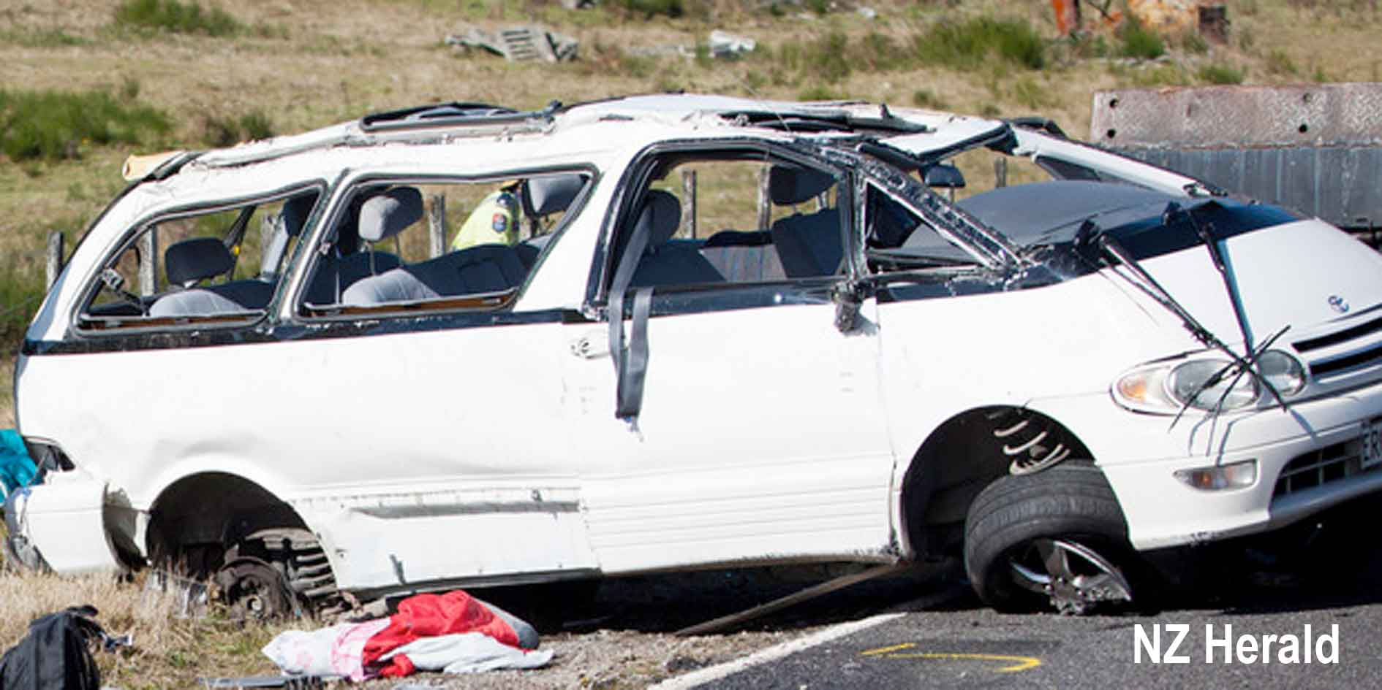

On Saturday 12 May 2012, a rented people-mover van carrying eight people crashed and rolled near Turangi. They were students from Boston University. Three were killed and four were injured. The driver was later charged and convicted.

This accident is worth examining in detail, because it appears to typify many tourist accidents: young male driver; distraction, probably as the result of fatigue; lack of seatbelt use; unforgiving road and unforgiving vehicle.

“Four Americans who were thrown from their vehicle and either killed or seriously injured could have survived had they had been wearing seatbelts,” a coroner says.

Boston University students Austin Perry Brashears, Ross Nicholas Jauberty, both 21, and Daniela Rosanna Lekhno, 20, died while Margaret Theriault, 21, suffered serious injuries after the crash on State Highway 46 near Mt Tongariro on May 11, 2012.

In his findings released this afternoon, Coroner Wallace Bain also found the three deceased would have died instantly due to severe head injuries.

Sixteen students travelled from Auckland to Taupo in two Toyota vans on the day of the crash. They were intending to walk the Tongariro Alpine Crossing.

After leaving Taupo, one of the drivers, Stephen Houseman, asked his seven passengers to ensure they all had their seatbelts on.

It was Houseman's first time driving on New Zealand roads and he had never driven a people mover before.

Despite Houseman's request, it seems either at Turangi - when they stopped - or a short time later, the four passengers did not have their seatbelts on.

As Houseman drove along Rangipo Rd/SH46, his vehicle crossed the white fog line off the sealed road, getting into grass and gravel.

It caused the vehicle to swerve. Houseman then overcorrected, causing the vehicle to flip four times, throwing the four passengers from the van.

Police calculated the vehicle was travelling between 75km/h and 102km/h when it began to flip.
No alcohol or drugs were involved.

The coroner said the facts of the case made "sobering reading and in particular for parents of young people."

"I endorse the view of the police crash analyst expert that, had the four students been wearing seatbelts, it is likely they would have survived the crash," he said.

"The same applies to the other student who received severe injuries by being thrown out of the vehicle."

While backing away from making any formal recommendations of his own, the coroner endorsed a recommendation from Clive Matthew-Wilson, editor of The Dog and Lemon Guide, for the stretch of road to be fitted with rumble strips on both sides.”

In their report to the coroner, the police concluded that the deaths were the result of driver error, combined with a lack of seatbelt use. The police specifically stated that there was nothing wrong with either the vehicle or the road.

While it is clear that the police made a thorough and comprehensive investigation of the events leading up to the tragedy, there are ample grounds for disputing the police conclusions as to the contributing factors.

To quote the Columbia Accident Investigation Board (CAIB, 2003)

“Many accident investigations do not go far enough. They identify the technical cause of the accident, and then connect it to a variant of “operator error” – the line worker who forgot to insert the bolt, the engineer who miscalculated the stress, or the manager who made the wrong decision. But this is seldom the entire issue. When the determinations of the causal chain are limited to the technical flaw and individual failure, typically the actions taken to prevent a similar event in the future are also limited: fix the technical problem and replace or retrain the individual responsible. Putting these corrections in place leads to another mistake – the belief that the problem is solved.”

The World Health Organisation has also seriously criticised the type of investigation carried out by the police in response to the Turangi accident:

“there is a tendency by researchers and practitioners to look for one or a few factors, when in actual fact they should be analysing multiple factors.... Any road traffic system is highly complex and can be hazardous to human health. Elements of the system include motor vehicles, roads and road users along with their physical, social and economic environments. Making a road traffic system less hazardous requires a systems approach — understanding the system as a whole and the interaction between its elements, and identifying where there is potential for intervention.”

The classic example of how a systems approach works to prevent road accidents is the Auckland Harbour Bridge. In the 1980s, the Auckland harbour bridge used to suffer one serious road accident every week. After a concrete barrier was installed down the middle, the serious accidents stopped immediately. There wasn’t one less 'hoon' or drunk driver, yet the accidents stopped simply because the road was changed in a way that prevented mistakes from becoming fatalities by preventing drivers from straying into opposing traffic.

After years of trying to lower the road toll by focusing on changing driver behaviour, the New Zealand government finally acknowledged the validity of the WHO position in 2013:

“The Safe System recognises that people make mistakes and are vulnerable in a crash. It reduces the price paid for a mistake so crashes don't result in loss of life or limb. Mistakes are inevitable - deaths and serious injuries from road crashes are not.”

However, as the example below illustrates, the New Zealand police continue to conduct serious investigations with a view to prosecution and with a willfully narrow focus which tends to focus on legal definitions of safe roads, safe vehicles, together with a fixation on driver behaviour as being the primary cause of most accidents, rather than a contributing factor in a series of events that lead to a particular road tragedy.

In particular, as the Turangi accident investigation suggests, the police appear to stubbornly resist any conclusion that acknowledges external factors that might have influenced the outcome of the accident in question.

It is worth noting that the police frequently refuse to use the generic term ‘accident’ to describe a road crash, instead, referring to road crashes as ‘incidents’. The stated reason for the use of the term ‘incident’ is that the term ‘accident’ implies that it wasn’t anyone’s fault. The police view is that most ‘incidents’ are preventable by modification of driver behaviour.

Using the WHO criteria, there were two roading factors and one vehicle factor, which probably significantly affected the outcome of the Turangi accident.

The lack of warning to the driver before he drifted off the road
Given the circumstances under which the accident occurred, it seems likely that both the driver and his passengers were tired, excited and probably distracted. It is clear, from the rear occupants’ failure to wear seatbelts, that there was no sense of the danger that the vehicle and its occupants were facing.

It seems highly likely that the driver and passengers were talking, with the driver perhaps either looking over his shoulder or glancing in the rear view mirror.

The above observations all fit the typical profile of an attention-deficit accident involving teenagers and young adults.

It is also possible that the driver drifted into a condition called a micro-sleep – an episode of sleep, which may last for a fraction of a second or up to thirty seconds. For the sleep-deprived, micro sleeping can occur at any time, typically without substantial warning.

Regardless of the cause of the driver’s distraction (which all parties acknowledge as the trigger for the accident), there is a strong possibility that, had the road been fitted with rumble strips, the driver would have been alerted to the danger of drifting off the road.

The Government’s own studies show that simple modifications such as rumble strips can drastically reduce road crashes, yet most roads don’t have rumble strips.

The lack of rumble strips on roads such as the one on which the fatality occurred, is all the more tragic given their relatively low cost of installation.

Road condition
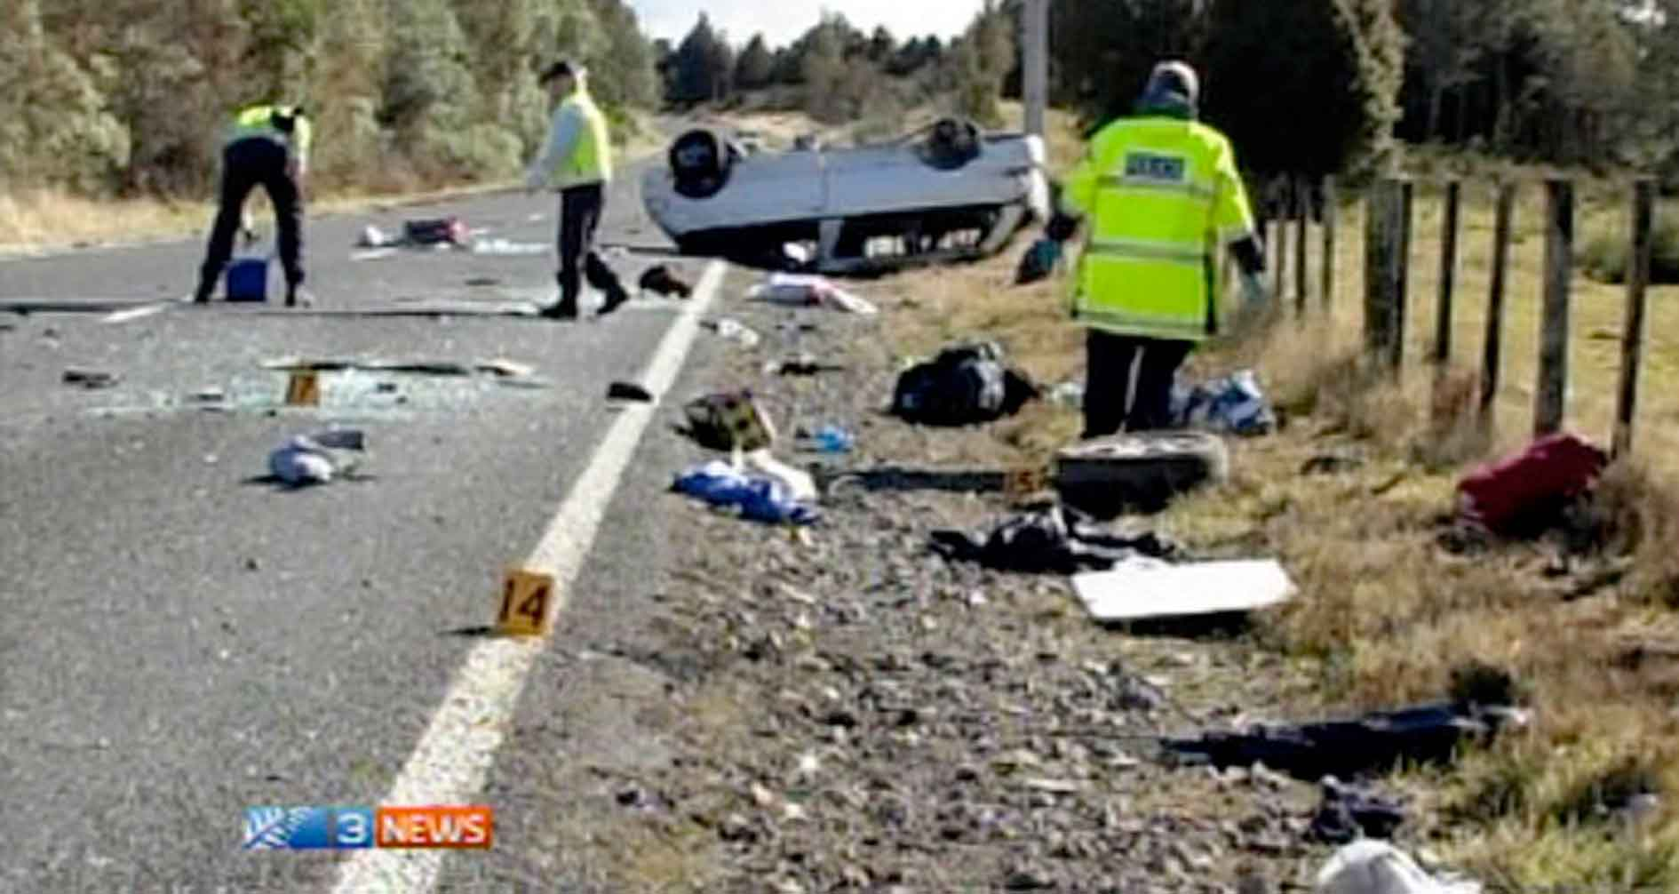

The condition of the Rangipo road was such that a vehicle that drifted off the road was highly likely to lose control.

It is acknowledged by all parties that, once the vehicle left the side of the road, the front-left wheel was in gravel. At this point a loss of control was highly likely. Given the clear manner in which the police report outlined this scenario, we will merely add the following observations:

Excluding the lack of rumble strips to warn the driver, there were two factors involved in the vehicle drifting into gravel and losing control. The first is that, at the side of the road, the white line effectively marked the edge of the tarseal.

Any vehicle that drifts over this white line would probably come into contact with the gravel.

Roading engineers typically specify the white line in this position (at the edge of the tarseal) in order to maximise the available roading space for vehicles.

It is difficult to over-emphasise the importance of both the white line and its position.

While driving, the driver’s eye notes the position of the white line and adjusts his own driving position in relation to it. If, instead of the white line being roughly parallel to the edge of the tarseal, the white line is 150mm further inwards towards the centre of the road, then the driver will probably adjust his own position 150mm inwards. This means that, should the driver drift over the white line during a period of inattention, there is a small band of tarseal on the other side of the white line, instead of a sudden drop into gravel. This factor occurs without any widening of the road.

It must be noted that the moving of the white line (and therefore the vehicle) towards the centre of the road mildly increases the risk of the driver drifting across the centre line instead, resulting in a head-on collision. However, by moving the centre line over 150mm to the left, this effect is somewhat negated.

The wider the centre strip, or strips, the narrower the road appears to the driver. The narrower the road appears to the driver, the slower he or she will tend to go.

The reason that New Zealand roads are not commonly marked this way is because they are designed to accommodate large road users; that is, trucks.

Narrower roads will generally only have a positive effect on smaller vehicles, for the reasons outlined above.

Narrower lanes tend to be annoying to truck drivers, especially if rumble strips are fitted.

Excluding situations where a narrower lane might pose a threat to safety (such as when they will tend to force a truck over the centre lane), there appears to be little justification for the current, deeply unsafe system of road marking.

Had the road at Rangipo been treated by the simple expedient of marginally narrowing the lanes through the moving of the white strip inwards on both sides of the lane, it is arguable that the accident might never have occurred.

There would be little or no cost difference in the building of the road.

No Electronic Stability Control on the vehicle
Based on the best available international research, it can be realistically theorised that, had the Toyota Lucida van in question been fitted with Electronic Stability Control (ESC), this fatality would, in all likelihood, not have occurred.

A 2006 study by the American Insurance Institute for Highway Safety (IIHS), concluded that ESC reduces the likelihood of

- all fatal crashes by 43%;
- fatal single-vehicle crashes by 56%, and
- fatal single-vehicle rollovers by 77-80%.

Moreover, ECS is specifically designed to prevent the type of accident that occurred at Rangipo, where a simple loss of control leads to a major incident.

It seems clear that, regardless of whether the Toyota Lucida van in question complied with the current law, the government-sanctioned absence of ESC on this vehicle can only be described as a serious and tragic omission.

Real solutions versus soft options
In relation to a recent surge in high profile tourist accidents, the government, perhaps fearful of offending tourists, especially those from major trading partners, appears to be afraid of legislating to make it more difficult for unsuitable foreign drivers to get behind the wheel of a rental car.
Instead, the New Zealand Transport Agency, police and tourist organisations are conducting a number of low-key strategies for solving the problem of tourist crashes. The main point of focus is education, both of the rental drivers, as well as the staff and management of rental firms.

The rental firms themselves are conducting a number of impressive-sounding initiatives, but which are unlikely to fully address the issue, for the reasons outlined below.

The stated initiatives of the tourism industry include:

- Observing the driving of those who appear low on confidence and ‘vetting’ prospective rental customers.
- A video on New Zealand roads and driving, which can be sent to clients when they book.
- The issuing of information stickers, brochures and links to websites.
- Cancelling the contract if police have serious concerns about a tourist's driving.
- A scheme to ensure a driver turned away or banned from one company cannot sign up with another.

There are a number of problems with this approach:

No mandatory code of road safety practice for rental industry

The tourism industry, after discussion with the Automobile Association and the New Zealand Transport Agency, recently announced that a code of practice for the rental of vehicles to tourist drivers was being formulated.
.
However, a confidential source with high-level experience in private sector public relations, had the following to say about the tourism industry’s proposed code of practice:

“My experience of having administered codes of practice in [another] industry is that companies deliberately flout the code and then say:
‘Oh dear, a junior staff member made a mistake: he didn't comply with our own company's rules.’
This is almost always total bullshit, but difficult to prove otherwise.
“And what do they do if someone continually flouts the code of practice? Chuck them out of the association, where they go on their merry way without complying.”

Asked about the overall effectiveness of codes of practice versus regulation, particularly in the rental car industry, the source responded:

“The code of practice is the perfect response from a PR point of view: it has no real teeth, but it allows all parties to be seen to be doing something.”

A similar approach was announced in 2014 with a number of initiatives, which, in restrospect appear to have done little to curb the problem of accidents involving overseas tourists in rental vehicles.

“Measures being developed by the rental vehicle industry in response to concerns over the safety of tourist drivers include:
• Observing the driving of those who appear low on confidence.
• A video on New Zealand roads and driving, which can be sent to clients when they book.
• Cancelling the contract if police have serious concerns about a tourist's driving.
• A scheme to ensure a driver turned away or banned from one company cannot sign up with another.”

Because there is no requirement that rental operators adhere to such codes of practice as may exist, there is a suspicion that foreign drivers who are turned down by one rental agency, will simply go to another.

The initiative above, in which the rental industry groups plan “a scheme to ensure a driver turned away or banned from one company cannot sign up with another” has no legal standing and would require 100% compliance across the industry. Otherwise, as stated above, after being turned down by one rental firm, the rejected driver could simply go to another firm.

This was the case with Dutch businessman, Johannes Jacobus Appelman, 52, who, on Queen's Birthday weekend of 2014, killed three people.

Appelman arrived in Christchurch on May 30 and rented a car, then crashed it a few kilometres from the airport while adjusting the GPS. The rental firm cancelled his contract after the accident.

The following day, Appelman hired a Subaru from another firm and, at about 3.55 pm, drove through a stop sign at a rural intersection near Rakaia at about 100km/h, killing Sally Vanessa Summerfield, 49, her daughter Ella Yasmin Summerfield, 12, and Ella's friend Abi Hone, 12.

2. Education ineffective
Many of the steps being undertaken by the police, NZTA, tourist bodies and the rental firms, involve education.

There are multiple problems with this approach. The first is that most research suggests that the worst drivers believe they are the best drivers. So, assuming that they realise the value of the education being offered, they don’t believe it applies to them.

Secondly, the educational approach assumes a similar cultural view, where road safety is the result of a series of planned and logical steps. However, as stated above, many cultures, including many from Asia and those from the Indian sub-continent, believe that life or death in any situation is a result of chance, fate or karma (the divine law of cause and effect).

This group is unlikely to believe, or grasp, the concepts behind the education that is being offered.

An additional problem is that highly robust research suggests road safety education simply doesn’t work. As with anti-drug education for teenagers, road safety education was based around the assumption that high-risk behaviour could be avoided if the persons concerned were informed of the consequences of such behavior.

Unfortunately, it is now widely accepted that anti-drug education for teenagers doesn’t work.

Similarly, The American Insurance Institute for Highway Safety, one of the most respected road safety establishments in the world, collated the results of dozens of other studies over the last 30 years.

Their conclusion:

“Research indicates that education has no effect, or only a very limited effect, on habits like staying within speed limits, heeding stop signs, and using safety belts.

'Until you check out the facts, who can argue against the benefits of education or training?' asks Institute chief scientist, Allan Williams. ‘But when good scientific evaluations are undertaken, most of the driver improvement programmes based on education or persuasion alone are found not to work.'”

3. Rental vehicles only half the problem
Around half of tourist accidents involve rental vehicles. A large percentage of the other vehicles appear to be privately owned. It would appear to be relatively simple to restrict the sales of vehicles to non-New Zealanders until they could demonstrate driver proficiency. The details of vehicles sold to overseas owners of motor vehicles then be entered into the same database that is proposed for tourists renting vehicles.

To explain further: legally, a vehicle’s ownership must be changed when a vehicle is sold. At present, both the buyer and seller can separately go online and notify the NZTA that the vehicle has been bought / sold. However, to use the online service, a New Zealand driver’s licence is required for both the buyer and the seller.

This requirement effectively excludes foreign drivers from using the online service. So, a New Zealand vehicle seller can register a sale of his/her vehicle, but the overseas buyer cannot complete the purchase by registering as the buyer.

While it is certainly possible for a foreign driver to simply drive his recently purchased vehicle without transferring the ownership, a large percentage of tourist buyers (even those driving budget vehicles), will want the security of a legally owned vehicle. Aside from risking fines, without a legal registration of ownership, foreign tourist vehicle owners cannot legally onsell their vehicle at the end of their journey.

Therefore, foreign tourist vehicle owners need to personally complete a change of ownership at an agent of the NZTA: The Automobile Association (AA), Post Shops, Vehicle Inspection New Zealand (VINZ) or Vehicle Testing New Zealand (VTNZ).

These agents would need merely to be instructed that vehicle buyers who are using a foreign passport or driver’s licence as identification when registering as the buyer of a vehicle, first complete the simple cognisance test detailed below. This test could probably be completed in a few minutes using a dedicated iPad or similar device, at the premises of the agent that was registering the change of ownership.

Once the cognisance test was passed, the change of vehicle ownership could then be registered. Also, the licence details of each of these foreign buyers, together with their vehicle details, would be entered into the tourist vehicle database detailed above.

Because an unknown percentage of foreign tourist drivers may choose to not register a legal change of ownership, such a measure can only ever be partially effective. However it would ensure that a majority of foreign tourist drivers had been given some kind of screening before they completed the purchase of a secondhand vehicle.

Transportation efficiency versus safety
It is worth remembering that New Zealand’s road transport system was developed with efficiency as a high priority. This means that many roads are built at low cost and many features that would reduce safety (such as might have prevented the Turangi tragedy above) are simply absent. This perhaps goes some way to explain New Zealand’s relatively high accident rate, and also the high rate of tourist accidents in certain areas.

By comparison, Sweden has the completely reverse approach:

“Planning has played the biggest part in reducing accidents. Roads in Sweden are built with safety prioritised over speed or convenience. Low urban speed-limits, pedestrian zones and barriers that separate cars from bikes and oncoming traffic have helped. Building 1,500 kilometres (900 miles) of "2+1" roads—where each lane of traffic takes turns to use a middle lane for overtaking—is reckoned to have saved around 145 lives over the first decade of Vision Zero. And 12,600 safer crossings, including pedestrian bridges and zebra-stripes flanked by flashing lights and protected with speed-bumps, are estimated to have halved the number of pedestrian deaths over the past five years... Road deaths of children under seven have plummeted—in 2012 only one was killed, compared with 58 in 1970.”

It seems clear that many tourist accidents are simply linked to a roading system which is the end product of a government that talks about a comprehensive approach to road safety, but in practice, tends to take relatively soft options, such as attempting to educate drivers and prosecuting offenders after the fact.

The government must, in the longer term, focus on three major issues:

- Keeping unsafe tourist drivers out of vehicles.
- Ensuring that the vehicles tourists drive are of sufficient standard to cope with mistakes by their drivers.
- Ensuring that, wherever practicable, the roads on which tourists drive are of sufficient standard to cope with mistakes by inexperienced, tired, confused and distracted drivers.

Useful steps to lower the tourist road toll

Restrictions on the rental of cars to recently arrived drivers
It is widely accepted that persons who have travelled long distances by plane are high-risk drivers, regardless of whether they originate from the country in which they have arrived.

Given the high risks involved in drivers operating rental vehicles when they are too tired, distracted, or impaired, it seems reasonable, and within the safe parameters of the Convention on Road Traffic, to impose restrictions on the operation of rental vehicles within a fixed period from arrival.
For example, it is arguable that no person (including people who are already citizens of this country) who have recently arrived from a foreign country on a flight that exceeds eight hours (not including time spent at airports), should be allowed to drive a rental vehicle within, say, 24 hours.
Such a restriction would not restrict a person’s ability to arrange a vehicle rental at an international airport, just to drive the vehicle concerned. It seems reasonable to assume that rental car companies can contract to rent vehicles to tourists upon arrival, then send out, say, a minivan to pick up these same tourists from their nearby accommodation 24 hours later.

Centralised control of driver eligibility
One obvious step to help prevent similar accidents in the future, would be a legal requirement that all rental firms immediately notify both the police and a centralised database when a significant accident occurs in a rental vehicle. The rental firms would then have to gain police permission before renting further vehicles to this driver or perhaps group.

Restrictions on who can rent and buy vehicles
Rental car companies and car dealers exist to make money. While rental firms may dislike having their cars damaged, the fact remains that any restrictions on the renting of motor vehicles may significantly decrease their turnover. Anecdotal evidence suggests that, from the top management to the front counter staff, there is overt or subtle pressure to meet sales targets. This pressure tends to cause rental companies to be strongly resistant to calls to screen prospective drivers more carefully.

Accordingly, there needs to be a clear, industry-wide mandatory code of practice that specifically requires that the person or company renting a vehicle takes all reasonable steps to ascertain that the person likely to be driving this vehicle is able to do so safely. As with certain health and safety legislation, this requirement would need to carry a serious legal penalty for knowingly renting a vehicle where the driver is clearly a high accident risk.

This is roughly analogous to the principle that an adult who hands a loaded gun to a person who is heavily drunk, is clearly culpable to some degree if this same person then shoots someone.
Responsibility for renting a vehicle to an individual whose ability to handle New Zealand driving conditions appears impaired, rests with both the rental company and the individual who approves the rental of this vehicle to the customer.
The same applies to both private and commercial sellers who sell to non-New Zealand drivers. There needs to be a clear responsibility for the seller not to enable a foreigner to buy or operate a vehicle without a clear transfer of ownership, which would not be legal until the buyer had first demonstrated an ability (perhaps via an interactive test at the place of transfer of ownership) to operate the vehicle safely.

Standardised driver cognisance test
New Zealand is a signatory to the 1949 Geneva Convention on Road Traffic and amendments. This Convention has now been ratified by the majority of car-driving nations (but, interestingly, not China).

It is clear that New Zealand’s obligations under the Convention prevent us from requiring that a person entering this country in possession of an International Driving Permit, pass a further theoretical or practical driving test, if the purpose of this test is to add an additional layer to the original test that the driver passed in his or her country of origin.

There appears to be a clear right on the part of the signatories to the Convention to impose general conditions on the use of motor vehicles within that country, and also, by implication, general conditions on the rental of vehicles.

Restrictions on the rental of vehicles to unsuitable drivers are currently somewhat arbitrary and appear to vary widely between rental companies. There needs to be a brief, standardised and accurate cognisance test that must be passed by any person who is renting a motor vehicle within three months of arriving in the country. This would include New Zealanders, in order to avoid the impression for such a test implied that foreign drivers were inferior or were being treated in a manner that might be construed as a breach of Convention obligations.

It has been argued by the Government that a cognisance test would breach this country’s obligations under the Convention. This claim does not stand much scrutiny. Regardless of which country a citizen may naturally reside in, they are still a high risk when fatigued and disoriented by lengthy air travel.

It is surely arguable that no reasonable interpretation of the Convention could suggest that any driver be allowed behind the wheel of a car if he or she is physiologically incapable of driving a vehicle safely.

For example, it is universally accepted that the possession of an International Driving Permit does not, ipso facto, permit a person to drive while drunk. It is a common law matter that is governed by the laws of that particular country.

It is similarly universally accepted that the authorities in any particular country have both a right and a duty to restrict the use of motor vehicles by someone who is drunk. Therefore, this accepted right must also, ipso facto, allow the authorities to take reasonable tests to ascertain if a driver is under the influence of alcohol, provided these tests are not arbitrary or unreasonable

Such a test may reasonably be defined as a cognisance test. Driver cognisance means ‘the range or scope of knowledge or perception’ and can be divided into three factors: the perception of factors regarding the operation of the vehicle, decision-making regarding these factors and vehicle operation based on these decisions.

Although the definition is relatively recent, the enforcement of traffic regulations through cognisance tests is as old as the motorcar itself. For example, since the early twentieth century, police officers have asked suspected drunk drivers to walk a short distance in a straight line. Failure to do so is taken as an indication that the driver is not sufficiently cognisant to safely operate a motor vehicle.

The cognisance test is a test of physiological competence at the time of the test, not knowledge or ability. For example, a person may have a university degree in road safety studies, but still be too tired, distracted, unaware or impaired to safely operate a motor vehicle.

It is similarly arguable that a rental car company has both a right and an obligation to ensure that drivers are not too tired, distracted, unaware or impaired when they rent and then operate a motor vehicle.

For example, hypothetically, a rental car company might reasonably ask all persons about to drive a rental vehicle, that they walk a short distance in a straight line, to demonstrate that they are not impaired before operating a vehicle. We are not advocating such a test, but this example points to the correct general direction that should be taken in establishing whether or not a driver is capable of safely operating a vehicle.

Just as it is both relatively easy and reasonable to test for impairment by alcohol, it is both relatively easy and reasonable to test for impairment by fatigue, distraction and general unawareness, provided the test is sufficiently standardised, universal in application and sufficiently discerning to provide useful screening of drivers.

It is now universally accepted that driving while fatigued has similar effects on drivers as driving while drunk. Not only is a fatigued driver more likely to fall asleep while driving, but fatigue also slows reaction times when it comes to responding to hazards on the road. A fatigued driver is much more likely to make poor decisions, but also, for example, miss a traffic control signal such as a stop sign, compared with an alert driver.

Regardless of what is impairing the driver, such impairment appears to be relatively easily tested, if the right criteria are applied.

Structure of the proposed cognisance test
In the 1930s, London Transport suffered an alarming number of accidents involving its bus drivers. Its solution was a crude but effective cognisance test. The test consisted of a small, flat-edged revolving wheel with a wiggly line on its outer surface made of solid dots (which, collectively, loosely resembled a winding road). The prospective bus driver was required to manually move a pointer so that it stayed in contact with this series of dots (see photos below).

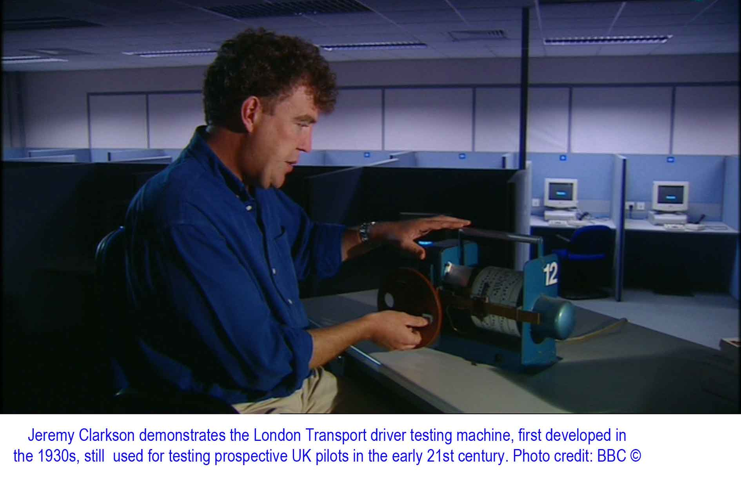
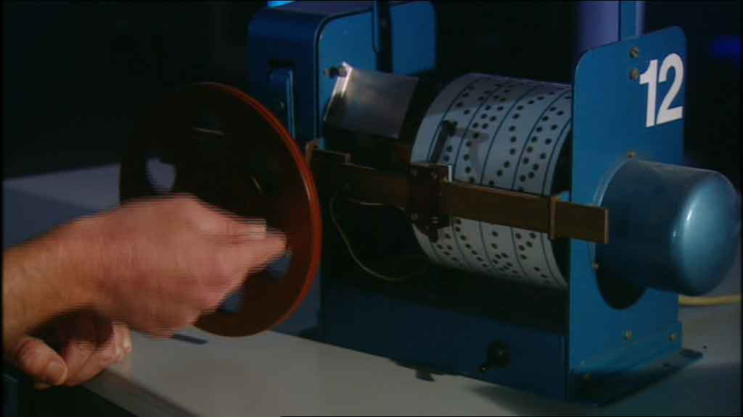

Accidents on London buses dropped substantially, apparently largely due to the success of this cognisance test; that is, its ability to weed out drivers who weren’t capable of safely controlling a bus.

Amazingly, this same test was still in use in the early 21st century for evaluating prospective pilots for the British Royal Air Force. Only 40% of prospective RAF pilots could pass this test: the other 60% failed, and were rejected.

Such a test could easily be developed as a smartphone and tablet app, and provide a simple but effective test of driver cognisance. The prospective driver would have to follow the wiggly line on the smartphone or tablet screen, which would move faster as the test progressed, effectively measuring both general cognisance (the ability to maintain a consistent pattern of functional behaviour) and reaction times (the ability to adapt to sudden changes in driving conditions).

In addition to the basic test, there could be several additional elements, such as the sudden appearance of an intersection in the simulated road on the computer screen, with a requirement that:

- the prospective driver slow for a GIVE WAY sign and stop for a STOP sign
- he or she move to the correct side of the road after this simulated intersection
- he or she be aware of a large car icon approaching quickly from one side of the intersection

It is failure of these elements that appears to be the major factor in most tourist-related accidents.

Such a test could effectively weed out those who were not capable of driving safely. If they failed a test, they could be offered a second chance the next day, after some sleep and perhaps study. The government rental car database would be notified that the prospective driver had failed the test, after which he or she would be barred from either driving any vehicle, renting any vehicle or re-sitting the test for 24 hours.

A multi-lingual facsimile of this same test would be available online, so the prospective driver could study during his or her period of rest, and thus gain the skills and understanding to pass the test after a period of recuperation.

Changes to road conditions
Many accidents involving foreign drivers involve confusion about where on the road he or she is supposed to be. There are two relatively simple steps that would go some way to alleviating this confusion.

- Installation of rumble strips, especially in high risk situations. NZTA research shows that rumble strips are highly effective at alerting a driver to a potentially dangerous situation, such as drifting out of their lane. The installation of rumble strips, on both sides of each lane, would help prevent many of the typical tourist accidents.

Horizontal rumble strips in the road leading up to major intersections would also be an effective and affordable way of alerting drivers to the impending danger. Many drivers appear to be unaware that the intersection is even there. It is arguable that the multiple fatality caused by the Dutch businessman Appelman would not have occurred had he been aware of the STOP sign in question.
Multiple studies have shown that horizontal rumble strips are highly effective at slowing vehicles and alerting drivers that a major intersection is just ahead.

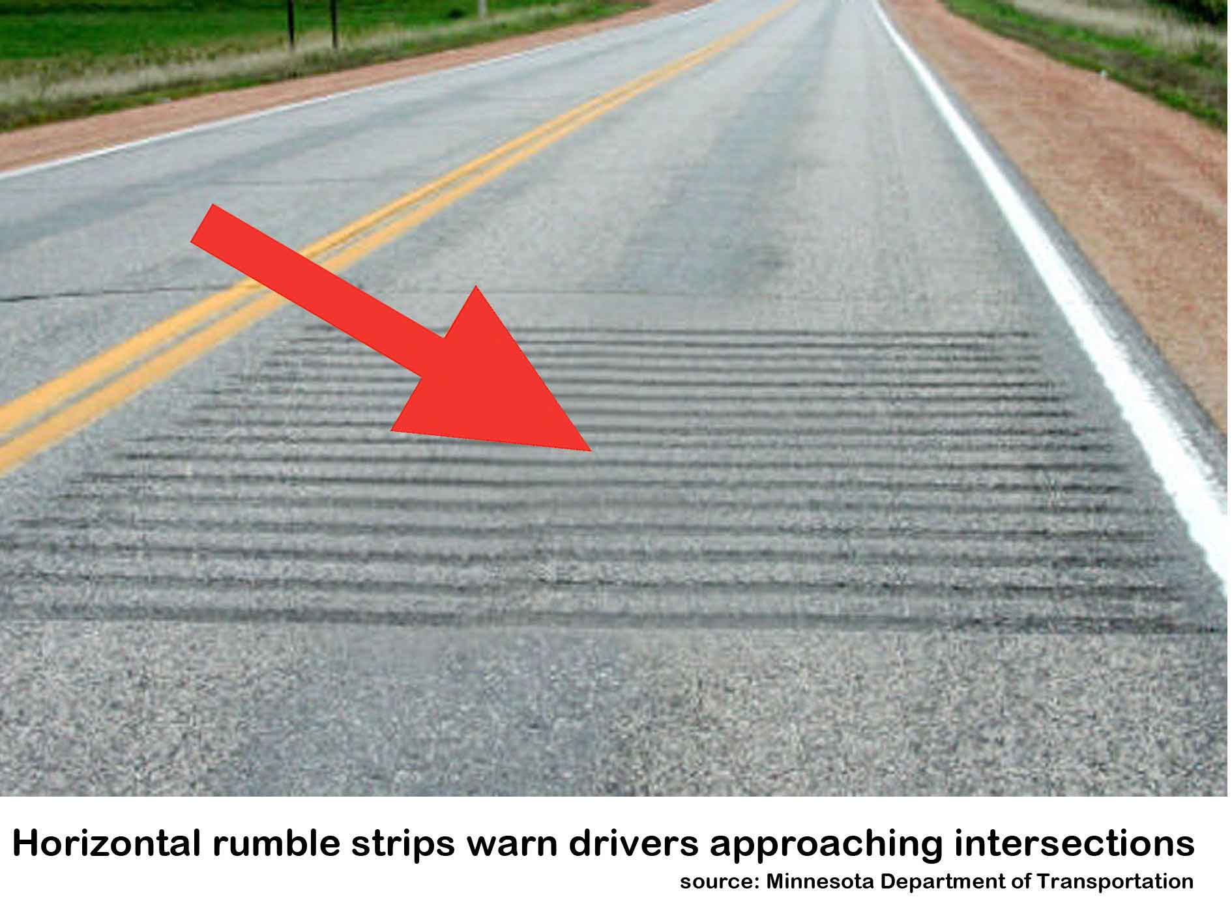

- Installation of multilingual and icon-based road signage on high risk roads.
3. Removal of gravel verges and moving the white line at the edge of the road on sealed surfaces.

Two factors contribute to accidents involving a vehicle drifting into gravel and losing control. The first is that, on many roads, the white line effectively marks the edge of the tarseal. Any vehicle which drifts over this white line would probably come into contact with the gravel.
Roading engineers typically specify the white line in this position (at the edge of the tarseal) in order to maximise the available roading space for vehicles.
It is difficult to over-emphasise the importance of both the white line and its position.
While driving, the driver’s eye notes the position of the white line and adjusts his own driving position in relation to it. If, instead of the white line being roughly parallel to the edge of the tarseal, the white line is 150mm further inwards towards the centre of the road, then the driver will probably adjust his own position 150mm inwards.
This means that, should the driver drift over the white line during a period of inattention, there is a small band of tarseal on the other side of the white line, instead of a sudden drop into gravel. This factor occurs without any widening of the road.
It must be noted that the moving of the white line (and therefore the vehicle) towards the centre of the road mildly increases the risk of the driver drifting across the centre line instead, resulting in a head-on collision. However, by moving the centre line over 150mm to the left, this effect is somewhat negated.
The wider the centre strip, or strips, the narrower the road appears to the driver. The narrower the road appears to the driver, the slower he or she will tend to go.The reason New Zealand roads are not commonly marked this way is that they are designed to accommodate large road users; that is, trucks.
Narrower roads will generally only have a positive effect on smaller vehicles, for the reasons outlined above.
Narrower lanes tend to be annoying to truck drivers, especially if rumble strips are fitted.
Excluding situations where a narrower lane might pose a threat to safety (such as when they will tend to force a truck over the centre line), there appears to be little justification for the current, deeply unsafe system of road marking.
There would be little or no cost difference in the building of the road.
- Installation of median traffic barriers and roadside fencing.
As the Auckland Harbour Bridge example suggests, separating opposing lanes of traffic almost always reduces the number of road deaths, even though it makes no difference to the number of bad drivers on the road.
A study by Monash University of the effectiveness of roadside fencing and median barriers concluded that: “reductions of up to 90% in death and serious injury can be achieved, with no evidence of increased road trauma for motorcyclists.”

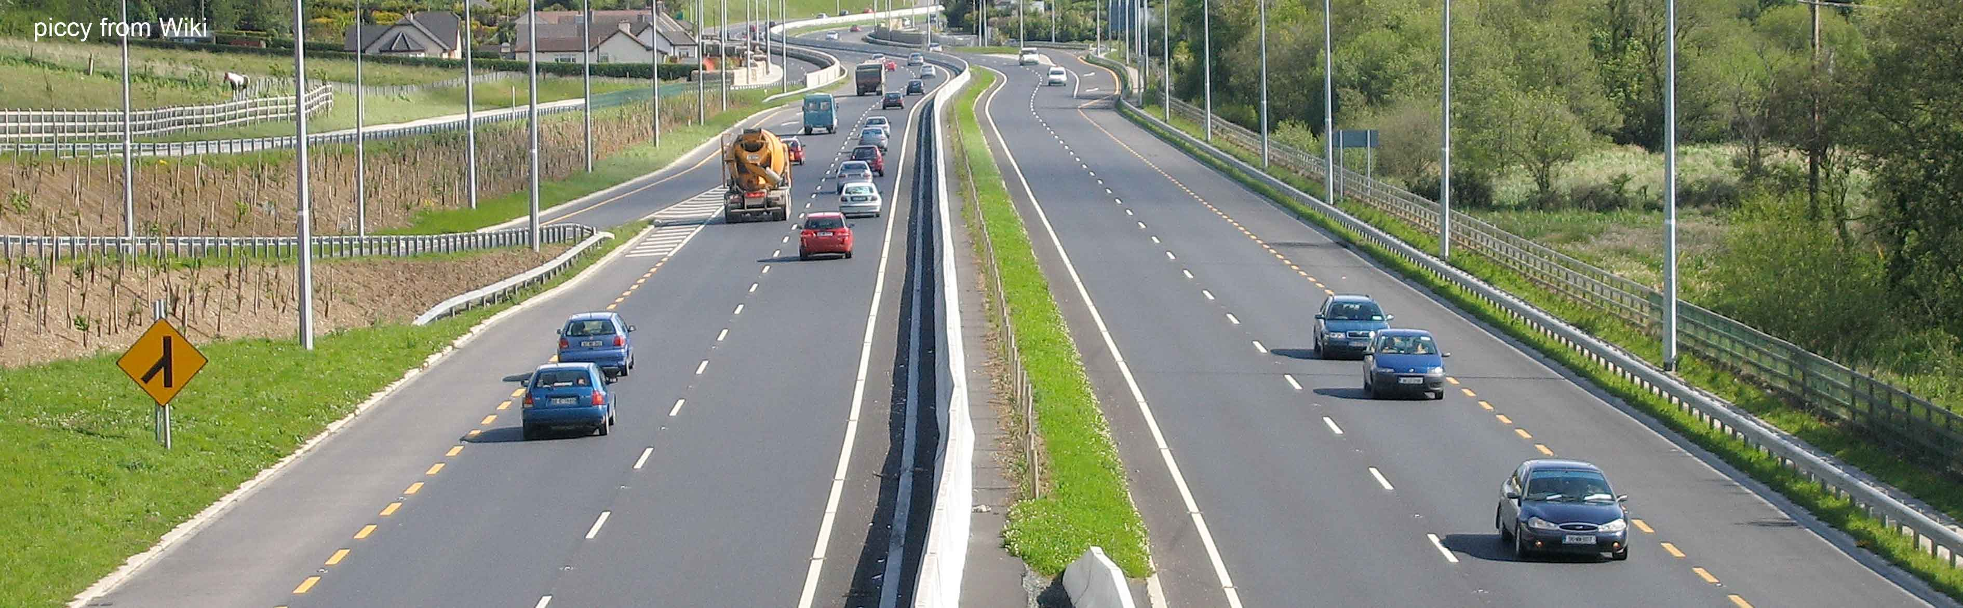
In addition, the appropriate installation of median barriers in high risk areas could have the added advantage of preventing reckless drivers overtaking on the wrong side of the road, together with preventing confused drivers from inadvertently straying into the wrong lane.
Clearly, there are both cost and logistical problems in installing median traffic barriers and roadside fencing on the entire roading system, and in particular, minor rural roads. However, tourist accidents tend to cluster around certain roads in clearly established patterns. If the government is serious about saving lives and injuries in high risk areas, it would appear mandatory to install the appropriate lifesaving technology.

Improvements to the rental vehicle fleet
There is widespread support for a legal requirement that all rental vehicles have electronic stability control.

The New Zealand rental vehicle fleet appears to be one of the oldest in the developed world. Whereas British rental cars are typically less than one year old, Some New Zealand rental cars are over two decades old.

Nearly two thirds of tourist accidents listed in the report quoted above involve a loss of control. Many of these vehicles don’t appear to be fitted with electronic stability control, which is specifically designed to prevent this kind of accident.

The government has already mandated electronic stability control on new vehicles. There is clearly a need to require this technology on vehicles that will be rented out to foreign drivers.

Encouragement of alternatives to self-driving

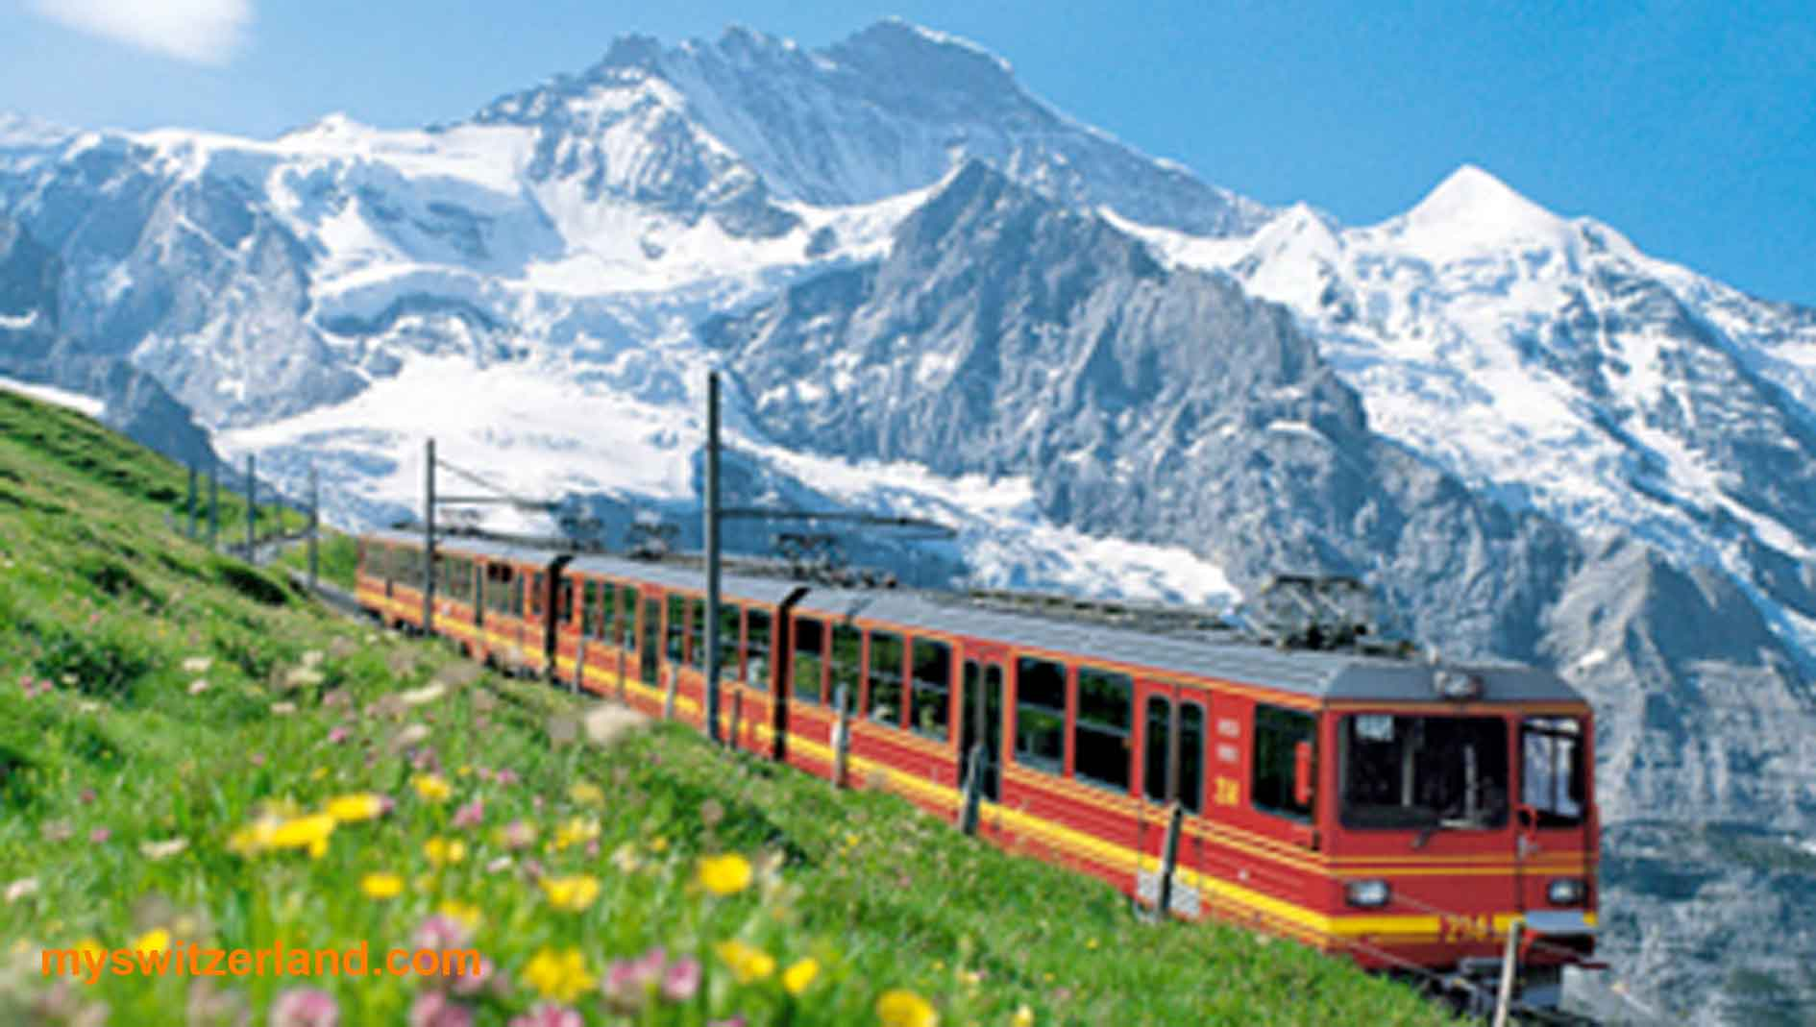

In Europe, in addition to cars, a huge percentage of tourist trips are made by bus, train, bicycle or even on foot.

By comparison,

“a survey of international tourists published in March 2014… found that driving was the most common way for tourists to get around New Zealand, with 63% driving themselves by car, 27% going by bus, 18% by campervan, 7% by plane, 4% by train and 1% by bicycle. (The total exceeds 100% because tourists use a variety of modes.)

Cost and value for money were given as the main reasons for driving. Some bought vehicles but 79% [of car drivers] rented, with price being the main guide.

Most drove for between three and four hours per day, but the shorter the overall holiday, the longer each day's driving. Unsurprisingly, tourists from right-hand drive countries found it harder to navigate.”

It is quite clear that many tourists’ use of cars to travel around New Zealand was a poor choice, for a variety of reasons, of which safety is one.

There are many other reasons that the use of personal cars for tourism impacts negatively on the tourist experience: New Zealand roads are often hard work and may require a huge amount of effort if the driver is going long distances. For example, navigating winding gorges in a large campervan can be a very stressful experience.

“An Englishman who lives in France was staying with a family member in Dunedin this summer. He saw a lot of the South Island, but always as a passenger. I asked how he enjoyed his trip. "Oh, fine," he said, a little wearily. "But all the driving! Don't you have trains in this country?"

The answer, sadly, is often no, thanks to a gradual decay of the national train system under successive governments. This is doubly unfortunate, because aside from offering considerable road safety advantages, there are large number of tourists who are baffled by a lack of trains running through some of the most spectacular scenery in the world.

The crisis over tourist accidents perhaps offers an unprecedented commercial opportunity to provide tourists with alternatives to driving. These would include simply making commercial drivers available to operate tourist rental vehicles, organised bus and minibus tours, and full-scale train operations aimed squarely at the tourist market.

Statistics contained within Rumble strips, median barriers needed to make roads safer http://www.stuff.co.nz/the-press/news/66630474/Rumble-strips-median-barriers-needed-to-make-roads-safer
Bad Trips: International tourism and road deaths in the developing world, FIA Foundation for the Automobile and Society, http://www.makeroadssafe.org/publications/Documents/tourism-report.pdf
Table summarised from Overseas drivers--part 1: Otago & Southland, Identifying themes within a Safe System framework of injury traffic crashes involving overseas drivers in New Zealand. Colin Morrison, Senior Analyst CAS, NZTA http://www.saferjourneys.govt.nz/assets/Overseas-Drivers-crash-analysis-to-advance-a-signature-project-part1-overview.pdf
Overseas drivers – part 2: Otago & Southland Testing statistical significance around at-fault drivers in fatal & serious traffic crashes locally in rural speed zones New Zealand Transport Agency, April 2014.
Source: New Zealand Transport Agency, February 2015
New Zealand Transport Agency response to a question from the author, March, 2015
Details obtained from the Abell Car Rentals’ website, April, 2015).
Details obtained from the Discount Car Rentals’ website, April, 2015).
Details obtained from the Escape Car Rentals’ website, April, 2015).
Source: New Zealand Transport Agency, February 2015
This is known from the age of the vehicle and also the vehicle make and model; dogandlemon.com keeps records of almost every make and model that is fitted with ESC.
New reality for family of Leeston woman killed in crash, Stuff, 24 February 2015. http://www.stuff.co.nz/national/66594286/new-reality-for-family-of-leeston-woman-killed-in-crash
Lions fans' serious crash prompts police warning to tourists - NZ Herald
Tourist did not know what centre lines were for. Stuff.co.nz 07/05/2014
That Sleep of Death - Dogandlemon.com
Driving With A Hangover Just As Dangerous As Drunk Driving, With Equal Fatigue, Slow Reaction Times http://www.medicaldaily.com/driving-hangover-just-dangerous-drunk-driving-equal-fatigue-slow-reaction-times-264645
Fatigue: Staying alert while you're driving Factsheet 24. Fact Sheet M6.3, New Zealand Transport Agency
Managing shift work - Business.govt.nz
http://sleepfoundation.org/how-sleep-works/myths-and-facts-about-sleep
Coping With Jet Lag and Sleepiness - WebMD
Work time and logbooks (Factsheet 2) | NZ Transport Agency
http://www.stuff.co.nz/national/9300869/Seatbelts-would-have-saved-US-students
Nigel Latta’s video series, “Surviving Teen Driving,” highlights research by Waikato University that indicates that teen drivers focus almost totally on the back of the car in front, rather than panning the landscape, as a mature driver does, looking for potential hazards. http://www.safeteendriver.co.nz/restricted
The Usability and Safety of Audio Tactile Profiled Road Markings, February 2009, Research Report 365).
Code of practice to better screen tourist drivers NZ Herald, Tuesday Mar 24, 2015
Tougher route for tourists NZ Herald, Wednesday Jul 9, 2014
A recent Sunday item (TVOne) on sugar consumption interviewed teenagers who had just bought large bottles of soft drink. They were asked whether they were aware the bottles contained 47 teaspoons of sugar. The interviewees responded that they did know and that they had learned all about the consequences of excess sugar consumption at school, but that clearly did not affect their behaviour, as they were still buying it.
[2] The Effect of Rumble Strips on Drivers Approaching Rural, Stop-Controlled Intersections, http://www.lrrb.org/media/reports/200642TS.pdf
This assumes, of course, that the median is continuous: on roads where the median is interrupted (for example, by intersections), it is vital that these intersections are ‘idiot-proofed’ to ensure that confused drivers don’t become trapped on the wrong side of the median, with no easy way of getting back onto the correct side of the road.
Overseas drivers – part 2: Otago & Southland Testing statistical significance around at-fault drivers in fatal & serious traffic crashes locally in rural speed zones New Zealand Transport Agency, April 2014.
Road kill - Must something be done about foreign drivers stuff.co.nz. Feb 27, 2015
Road kill - Must something be done about foreign drivers stuff.co.nz. Feb 27, 2015

